Extend Your Storytelling with the Arts:
Let Creativity be the Main Player!

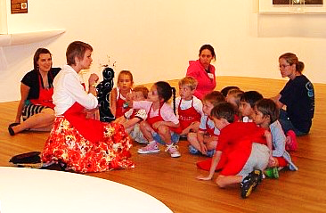

An innovative, learn by doing workshop featuring live drawing, 3D art making, paper crafts, and more you can use without delay for winning library programs! Include all learners using multi-disciplinary approaches to awaken imaginations, engage active participation and encourage teamwork. Plus, learn new activities to boost creativity for Maker Spaces.​
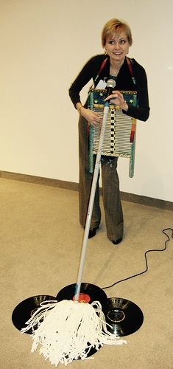

​ Celebrating Creativity through ARTful

approaches in storytelling!

Ann Marie Newman is a creative dreamer, artist and performance storyteller. From 2007-2014 she was the Storyteller in Residence at the Dallas Museum of Art where she became well known for using a variety of materials and techniques to create sensory-rich storytelling programs. Through her creative work, Ann Marie seeks to communicate universal themes about the human condition, in hope of building bridges of understanding between people from all walks of life.
Multi-disciplinary storytelling programming provides multi-sensory, whole body engagement.
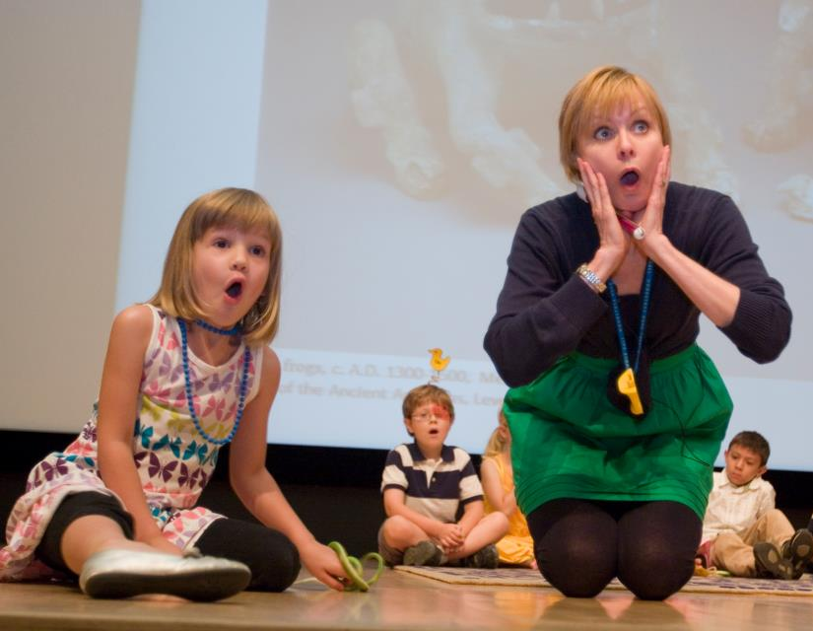
- This aids all learners to move beyond imagination and into the realm of creative expression. Why encourage creative expression?

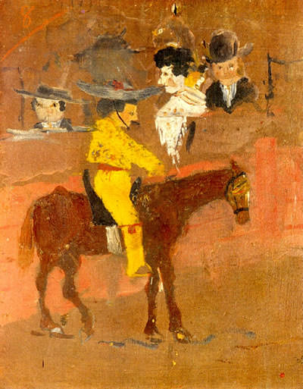
We are born with Imagination.
Creativity is Learned.

- Every child deserves a chance to learn how to create.

The Picador, Oil painting by Pablo Picasso aged 13.

- At age seven, Picasso began formal art lessons. His first instructor was his father, Jose Ruiz Blaso, a painter and professor of art.

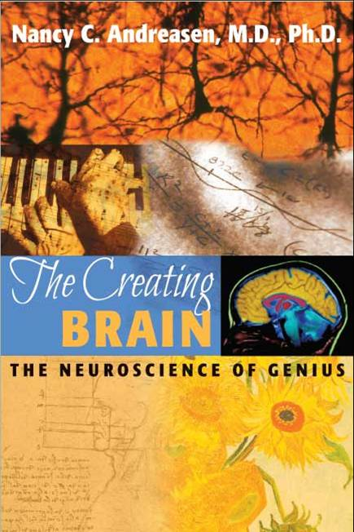 In the book, The Creating Brain: The Neuroscience of Genius, author Dr. Nancy C. Andreasen identified three factors necessary for imagination to rise to the level of creativity.

- Original: No copying!
- Have Utility: Need not be practical, only of use to someone else. Entertainment, appreciation, inspiration have utility in the arts.
- Product: Separate from the creator for others to engage in.

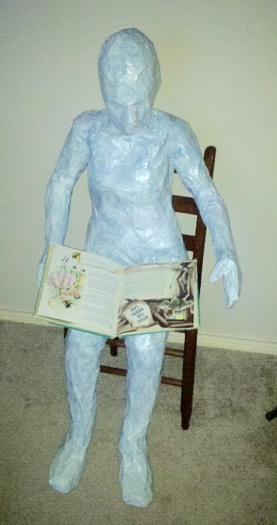
“Creativity = imagination plus originality, utility, and the ability to mold our imaginations into independent forms capable of stirring the imaginations of others.”
Dr. Nancy C. Andreasen
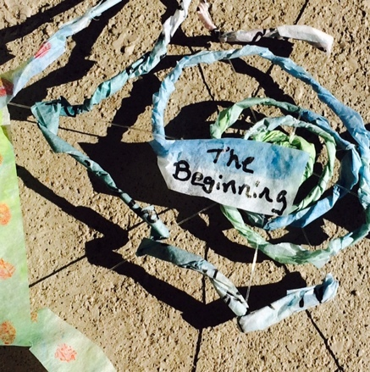
Overcoming preconceived ideas about what art
“should look like”.

Let’s admit it, we’ve all experienced criticism of our creative efforts by others at some point – okay, MANY points - in our lives starting from an early age. It’s not pleasant. For many, it is so unpleasant, future creative endeavors can be permanently hindered. Squashed! Eviscerated! Exterminated!

Enter stage left our hero; author/artist, Peter H. Reynolds. All of his books are awesome, but which is my favorite?

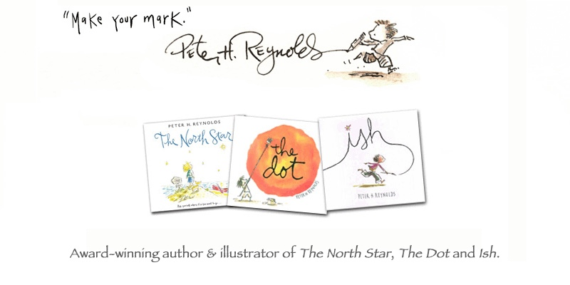
Ann
Marie’s
Favorite!

Ish is so much fun to share with not only kids, but adults as well. Everyone is capable of making an “ish” drawing!

“Thinking ish-ly allowed ideas to flow freely.” Peter H. Reynolds

“…a tribute to an approach to thinking – and relaxing — about your art, your writing, your craft. Your life.” Peter H. Reynolds
Activity suggestions for the book, Ish:

- Make Ish drawings to share along with the story!
- Drawings can be modeled after the book’s illustrations. These can be easily stored and shared along with the story over & over again. Win!

- OR, draw the images live during the telling or reading of the story on an erasable white board or large sketch pad. Don’t worry about how you draw – they are ISH drawings! Your playfulness, and freedom from making a “perfect drawing” is the MAIN message. Be an example of courageous creativity!

- Invite your listeners to make an “Ish” drawing during or immediately following the story program. They can add color afterwards with crayons in the Maker Space, or upon returning to home.

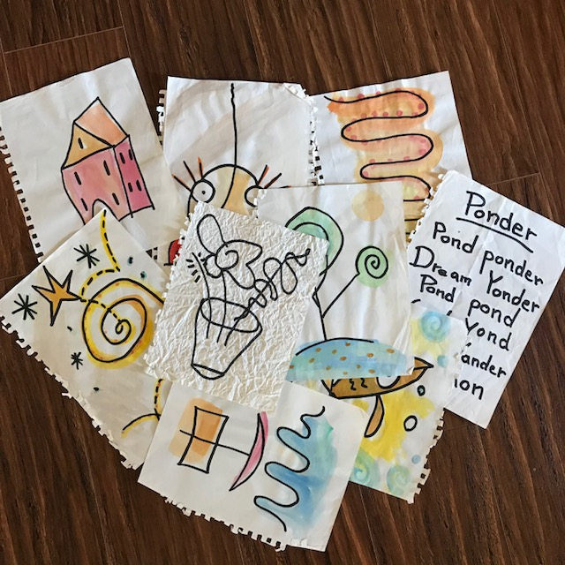
Say “goodbye” to your inner art critic and have “ISHly” good fun!

Still struggling with expectations of how art “should look?”

Perhaps? Well then, time for German artist, Paul Klee to enter stage right.
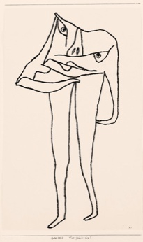
Take a look at this work titled, What Is He Missing? Does “he” look real to you? Where is his head! Hhmmm…looks like he’s thinking with his stomach to me. I think this must be one of those “Ish” drawings.

Paul Klee would intentionally mimic children's artwork by using ambiguous shapes and form. He liked to "take a line for a walk".

His highly individualistic work reflected:
- A childlike perspective
- Moods - often dry humor
- Beliefs
- Love of color
- Musicality - he played the violin

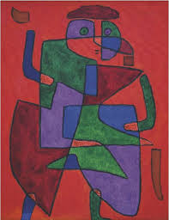
Here, Paul Klee takes a line for a walk to make this painting titled, “The Man of the Future.”
It sold for $3,717,600 at Sotheby’s London in 1990.

Time to take inspiration from Paul Klee, and a classic draw and tell story located at this fabulous website http://www.drjean.org (type in search “here, kitty, kitty”). This story is also in The Story Vine by Anne Pellowski. Now, let’s make Ish art! In this case kitty-ish art.

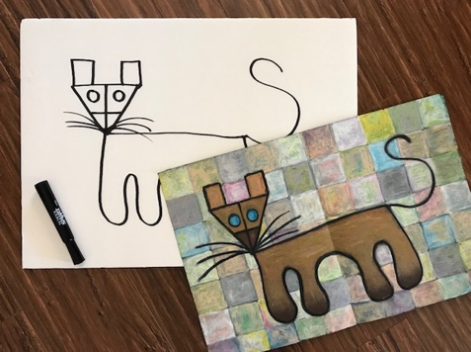 Draw and Tell materials:
- White board: full size if your group is large, or can be halved for smaller groups. The Dollar Tree sells them for $1 each.
- Black Marker: large
- Easel, or if you are comfortable, you can prop the board upright on your knee as you draw.
- Pencil: You may want to lightly draw the lines with a pencil beforehand, then during the telling, trace over them with the marker. This is a good option for beginners to Draw and Tell storytelling.

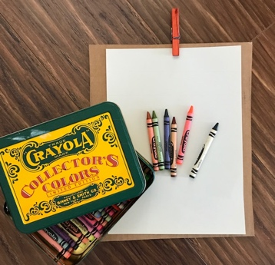 Optional materials:
- Clipboards for listeners: These can be made cheap from sturdy, upcycled cardboard rectangles and a clothes line clip.
- 8x11 drawing paper: one per person
- Crayon or Pencil per listener: This allows the audience to create a drawing along with you. It does add several minutes to the telling time, but it produces an individual work of art for all involved.
- Crayons: For coloring the drawings in the Maker Space.
- Praise: Acknowledge how wonderfully different everyone’s drawings are. All are unique and wonderful in their own way!

“Art is a creation of the eye and can only be hinted at with words.” Baldessari

“Draw and Tell tales are for ears and eyes. By showing the active progression of a story, eyes are engaged, ears are opened, imaginations are ignited.” Ann Marie Newman

Recommendations for Draw and Tell Stories:

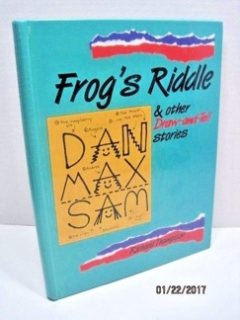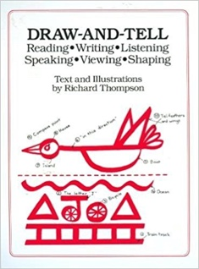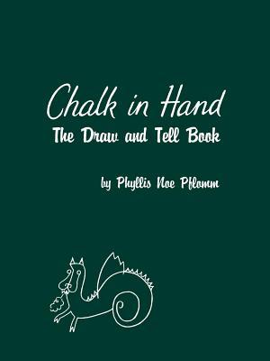

- Chalk in Hand: The Draw and Tell Book by Phyllis Noe Pflomum
- Draw-And-Tell: Reading*Writing*Listening*Speaking*Viewing*Shaping by Richard Thompson
- Frog’s Riddle & other Draw and Tell Stories by Richard Thompson

Websites:
- www.drjean.org (Classic draw and tell stories, including “Here, Kitty, Kitty.)
- http://meusenotes.blogspot.com Excellent source!
- https://www.pinterest.com/ Type in draw and tell to find stories.

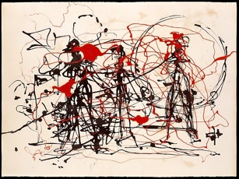 Take a Line for a 3D art walk!
Untitled, Jackson Pollock
(with a little help from Jackson Pollock)

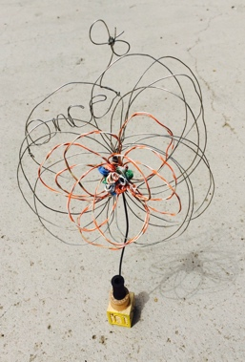
A fun option to a drawing tale, is to take art wire (Twisteez Art Wire is the best!) and play around with lines, shadows and contours! If possible, play Jazz music. Pollock listened to it while he painted.

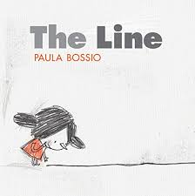 A few story/theme connections:
- All spider stories, especially Anansi the Spider!
- Books & stories relating to music.
- The Line by Paula Bossio is fun for little ones!
A Passion for Paper and Stories:
Paper Art + Story = Playful Fun!

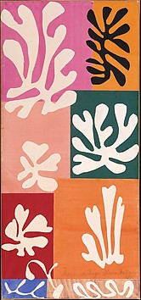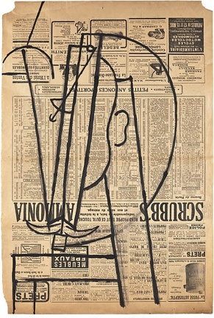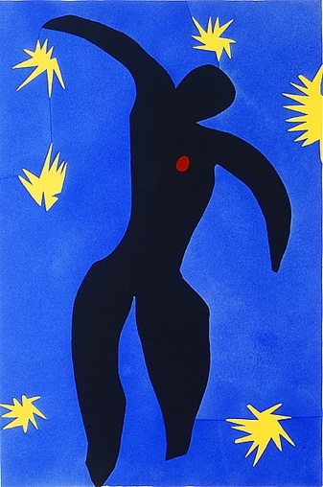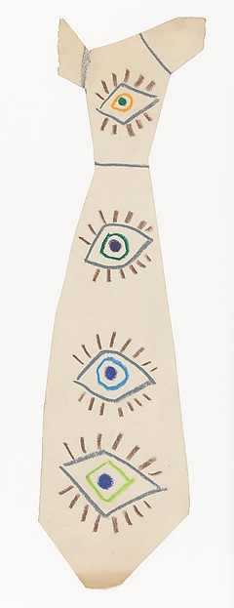

Left to right: Snow Flowers, Henri Matisse, Head of a Man with a Mustache, Pablo Picasso, Icarus, plate viii from the illustrated book, “Jazz”. Henri Matisse, Tie, Pablo Picasso

There are so many things that can be done with paper, a relatively inexpensive art material, during a story program!

Cut and Tell Stories:
- http://meusenotes.blogspot.com is an excellent online source!
- Paper Cutting Stories from A to Z by Valerie Marsh
- Paper Stories by Jan Stangl

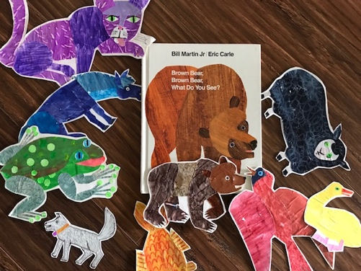 There’s more we can do with paper!
ALL Eric Carle illustrated books are an endless source of inspiration for using finger painted/painted papers to make collages. Which, by the way, is how Henri Matisse made the above left, Snow Flowers.

There’s even more we can do with paper – Origami!

- Make a Snapper Mouth!
- Origami Snapper Instructions: https://www.youtube.com/watch?v=SNnfVE7xvbc
- Origami Snapper (More detailed activity)Instructions:
https://www.youtube.com/watch?v=ybKPN9vNlHc

- Instead of using printed origami paper, use plain white printer paper! This allows for more creativity. The paper can be drawn on, colored, or painted. It can be done before, or after folding. How the paper is decorated can be based on a particular story that day!

I wanted my snapper mouth to sing-a-long with me about how much I love art. Here, I made a colorful pattern inspired by Ukrainian-born artist, Sonia Delaunay.

Directions: Draw five circles and five lines. Allow them to overlap. Then, color in the white spaces between the lines. Fold into a snapper mouth and add eyes. Voila!

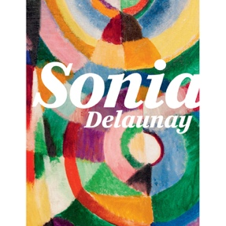 + 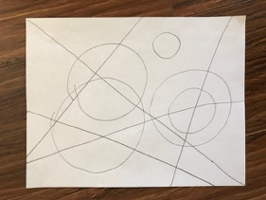 + 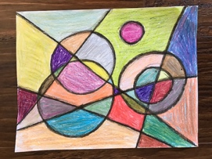 = 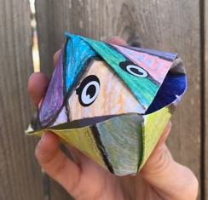 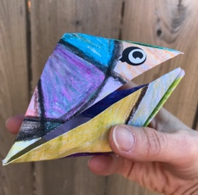

Need a simpler option? How about this easy-peasy paper puppet. The paper can be decorated before folding or after like the above, and it moves its mouth too!
Online directions: http://artxplorez.com/do-it-yourself-crafts/paper-hand-puppets
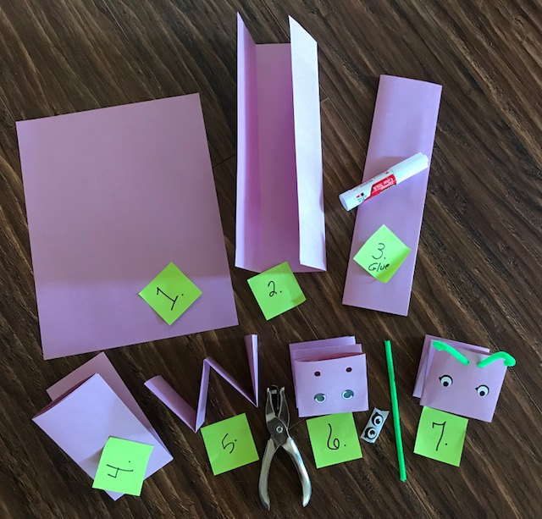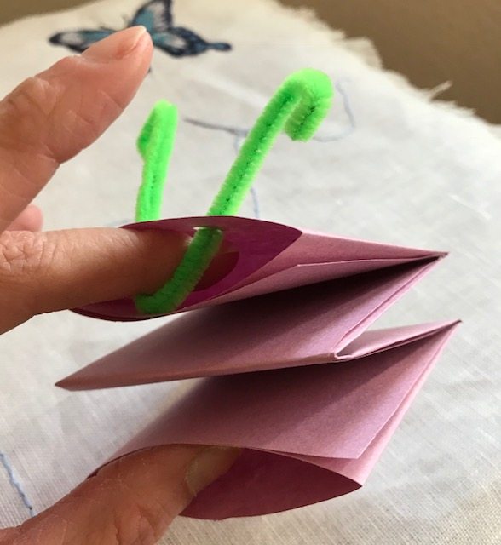

Masks! Masks! Masks!

A fun addition to storytelling, these masks are light weight, sit on top of the head. That means the wearer can see, hear, and move around with ease. Phew!

The easiest, cheapest mask to make in the paper plate mask! It doesn’t hold up long, but while it does, it’s good fun.

Materials:
- White paper plates
- Scissors
- Black marker
- Markers or crayons is desired.

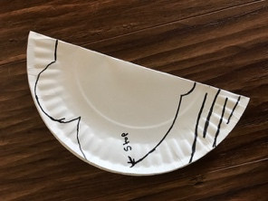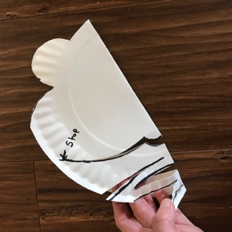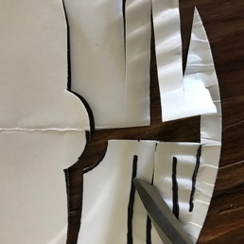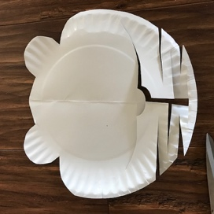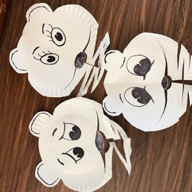
The Three Bears! Prepare the patterns beforehand, then thrill your listeners by cutting them out in front of them. The accordion cut that expands the bottom to fit over a head is fun for the kids to see happen before their eyes.
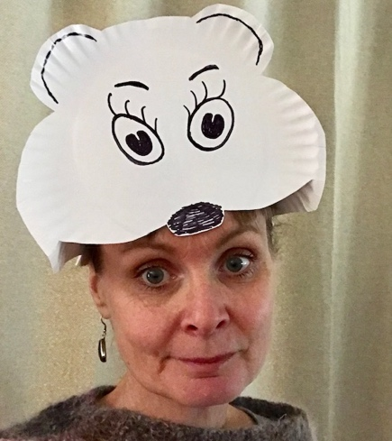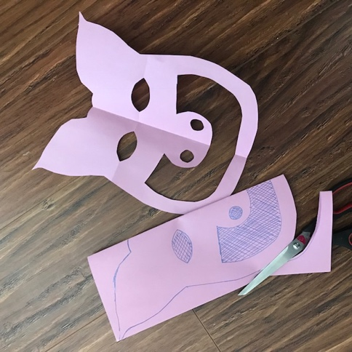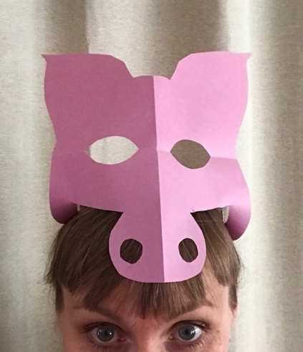
It’s Mama Bear! You can also make pigs, frogs, dogs…all kinds of critters with standard and legal size paper. The mouth fits over the head, and can be clipped on with bobby pins quickly. Prepare pattern ahead and cut live for DRAMA!
Bring that old classic, the Greek myth of
Theseus and the Minotaur to life for today’s youth with a mask!
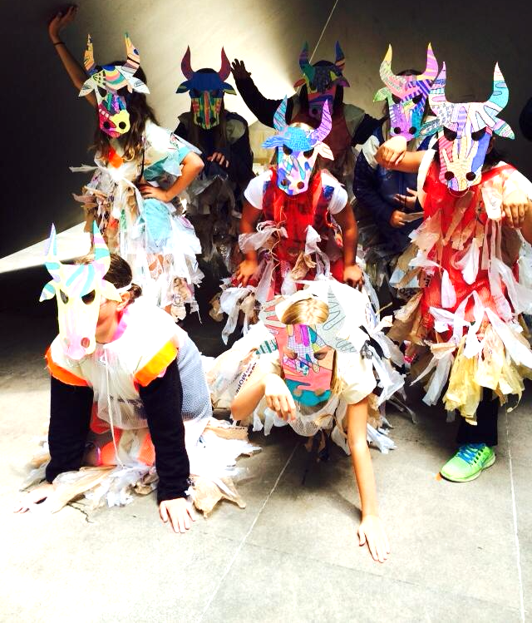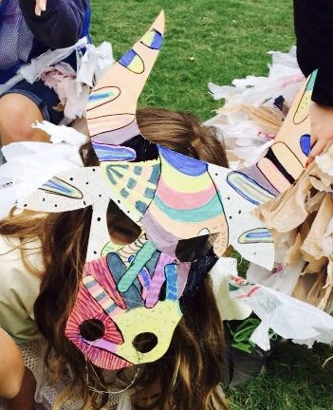

For a letter size pattern go to: https://www.annmarienewman.com Click on the StoryART patterns page. The masks in these images were enlarged, and cut from Dollar Tree Poster Board (three masks per board). They were then hot glued to Dollar Tree googles. This enabled a more comfortable fit & afforded lots of movement with the mask remaining in place.

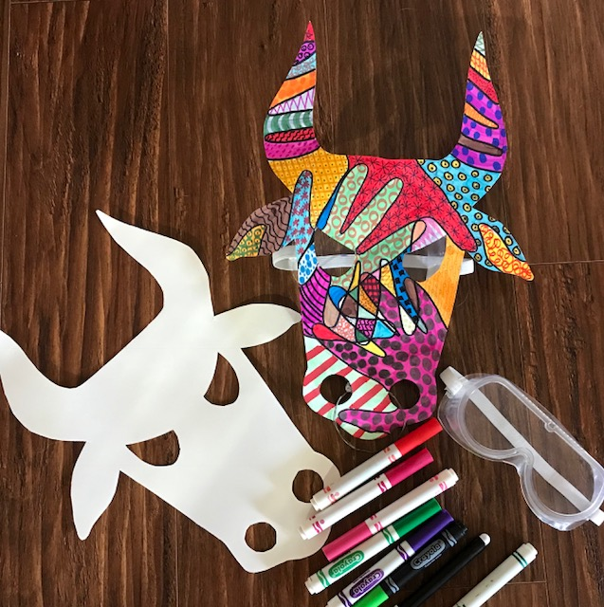
Simple Directions:

* Trace hands in overlapping design.
Do not overdo!
* Next, use markers to create colorful patterns in the
white spaces.
* Cut out mask and have fun!
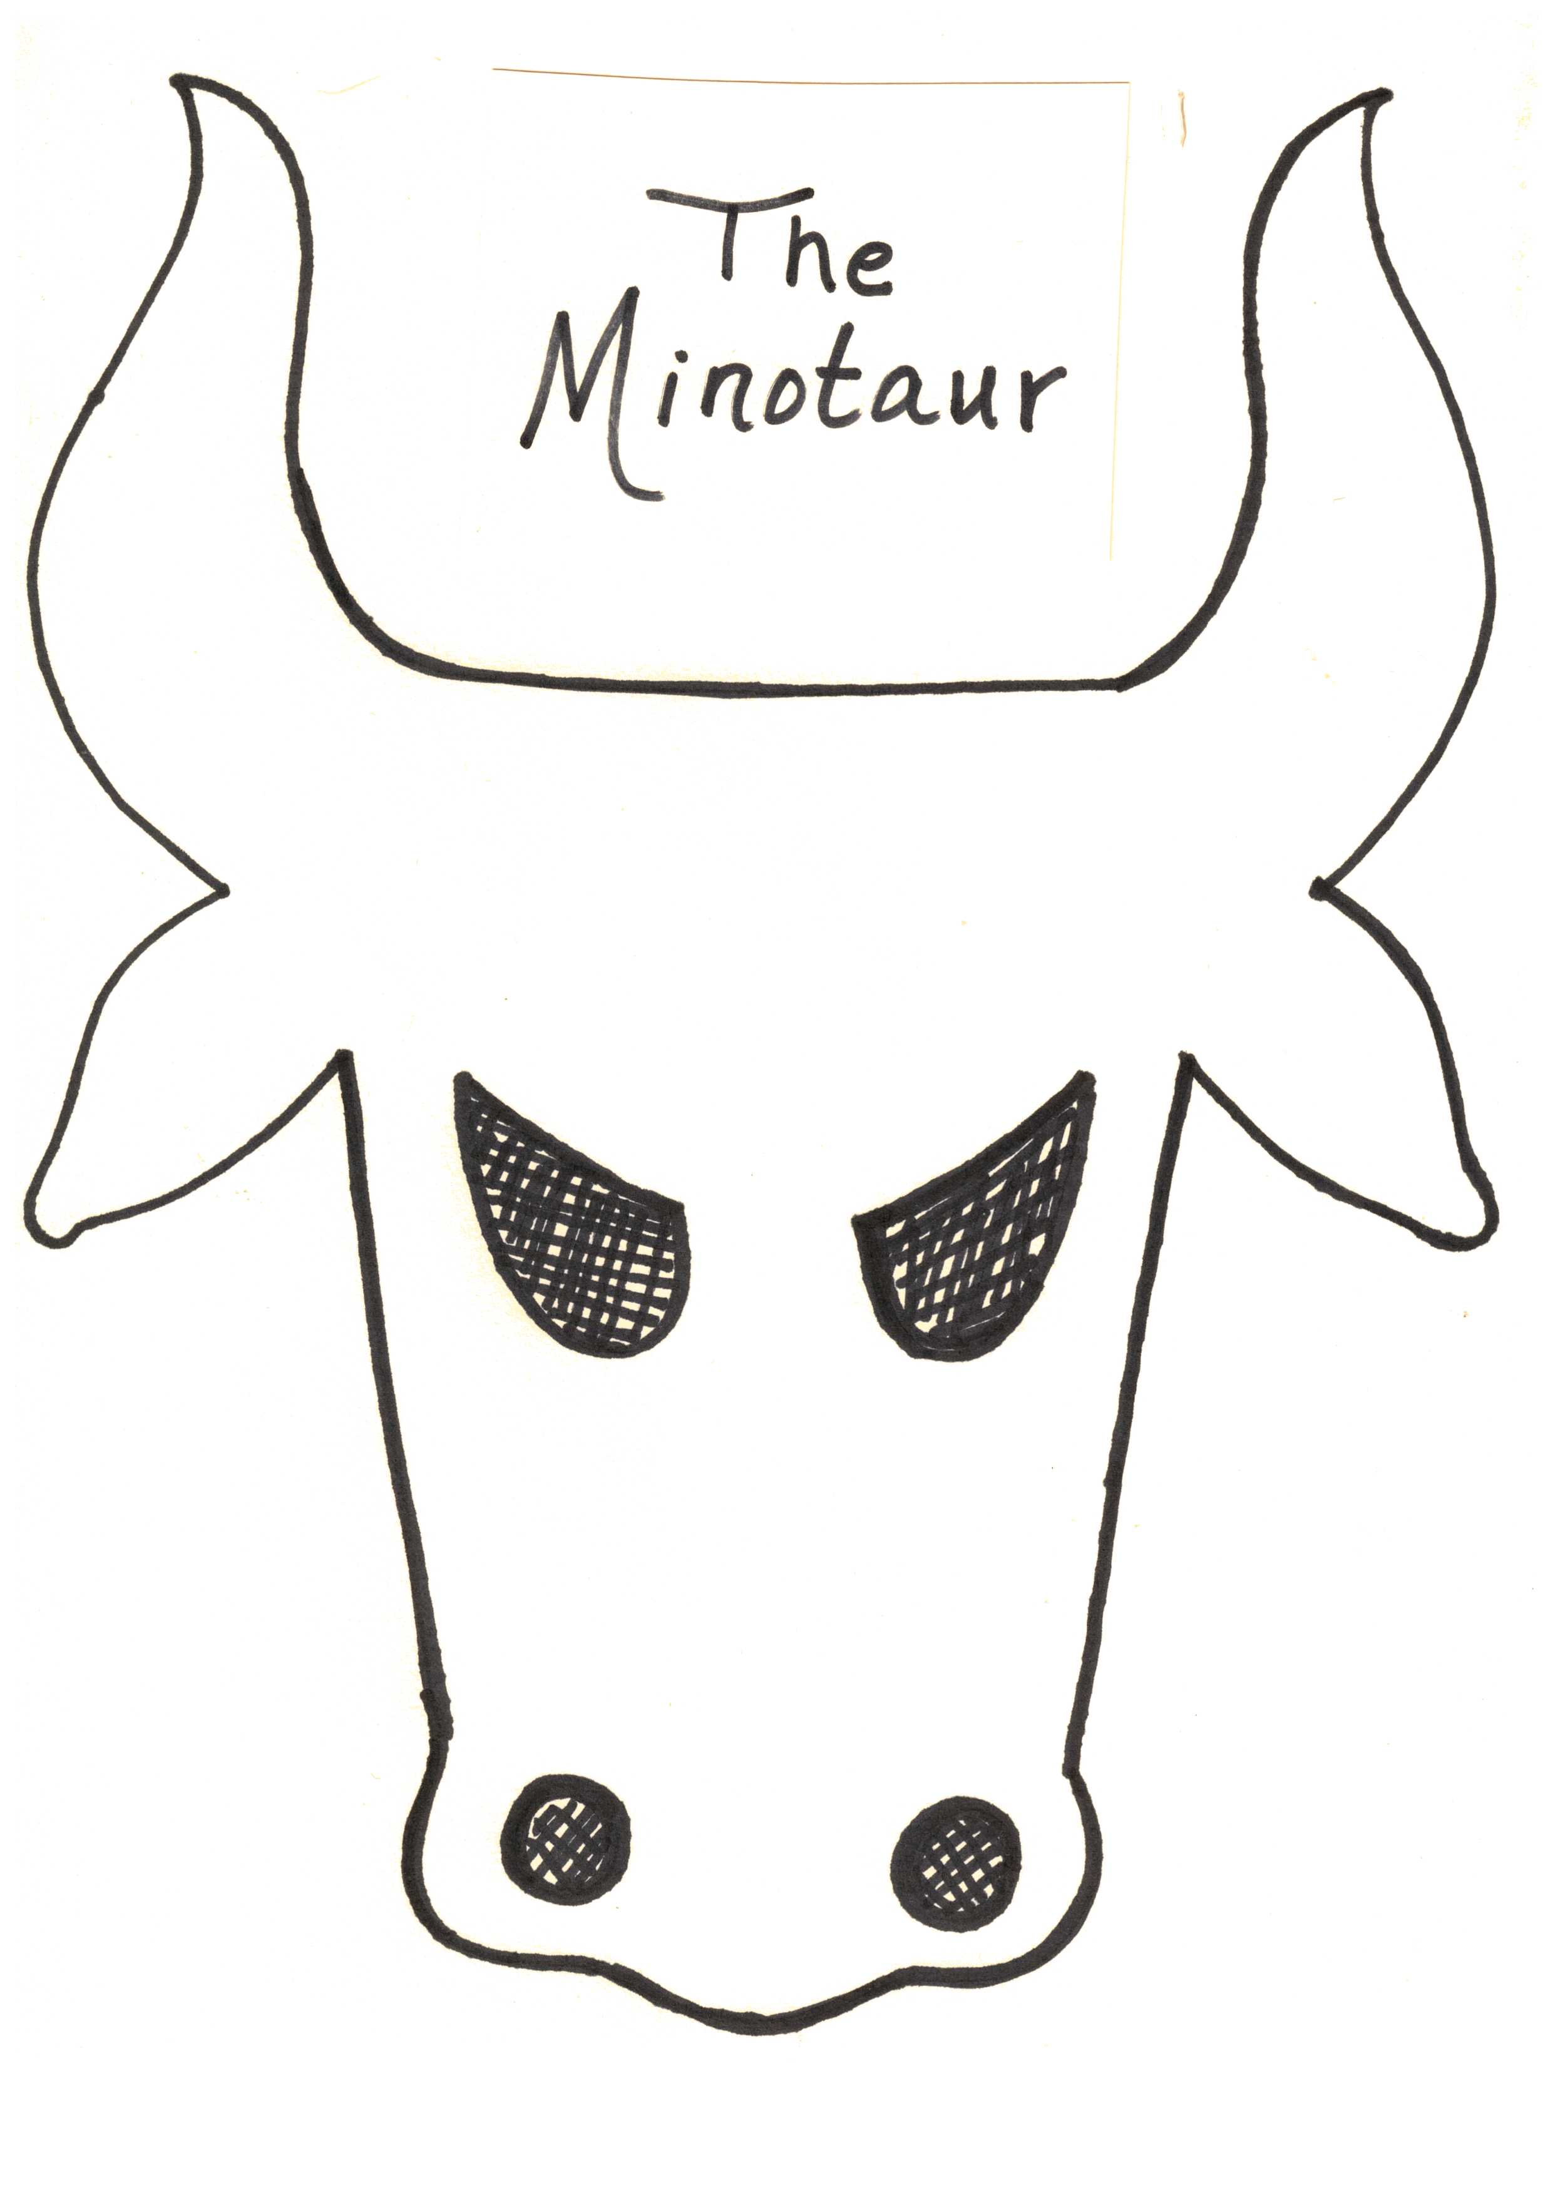

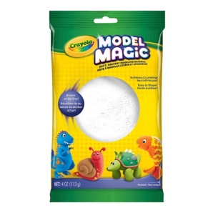 Model Magic – It’s a Miracle!

It’s clean, easy to work with, dries well, can be painted using tempera paints, or colored on with markers! What’s not to love? A 50% off coupon given out regularly by Michael’s makes it affordable too.

My favorite way to introduce working with clay is to tell the story, Grandma Spider Brings the Light and demonstrate how to make a pinch bowl. The book below is excellent, but I also recommend http://www.marilynkinsella.org/Fabulous%20Folktales/Grandmother%20Spider%20Brings%20the%20Light.html This sight gives multiple versions of this tale with background cultural information.

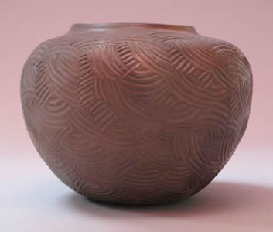
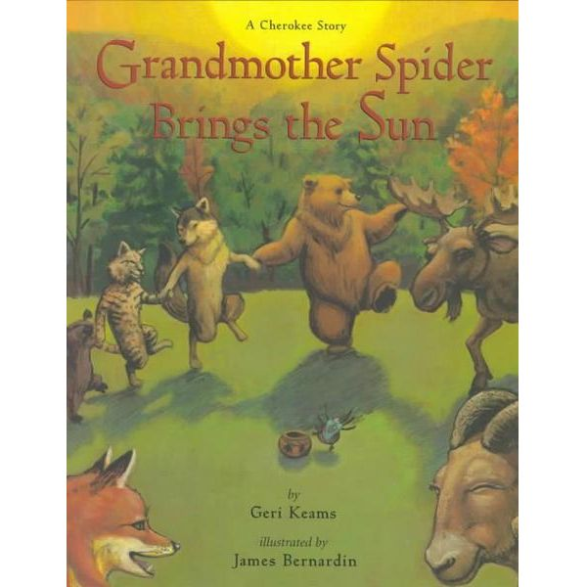

Introduce how Pinch Pots are made while Grandma Spider is making her bowl to hold the sun. Have a few volunteers make one along with you!

Just a small 1 ½ inch ball of Model Magic is needed per person. This is a fun activity for the Maker Space!

How-to Steps: 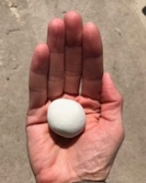+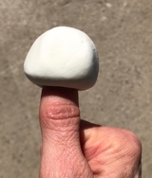 +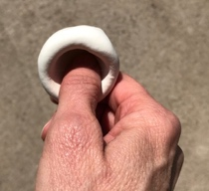+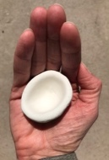 =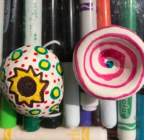

Getting Inspiration from the Masters!
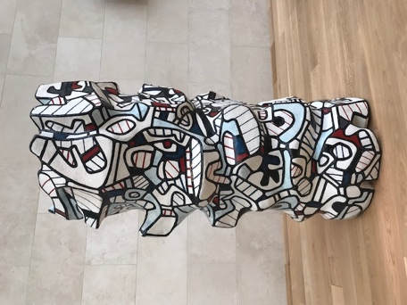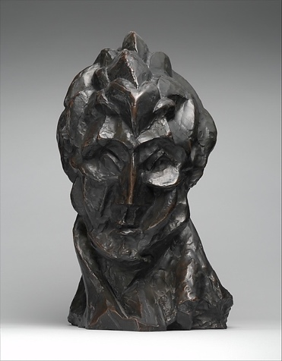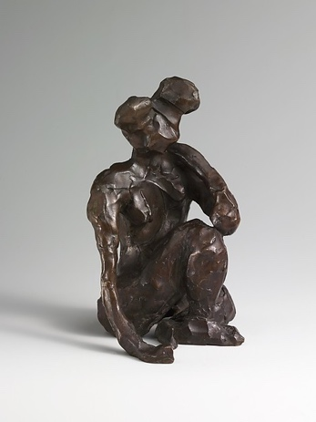
L to R: Tower of Lace, Jean Dubuffet, Head of a Woman, Pablo Picasso, Seated Figure, Right Hand on Ground, Henri Matisse

The Great Mystery Baggie Sculpture! A playful, fun, fail-proof activity.
- Place a ball of Model Magic into a plastic bag, squeeze and shape it, then carefully remove your shape.
- Have fun turning it around carefully while guessing what it is.
- Allow to dry. Paint or decorate with markers.
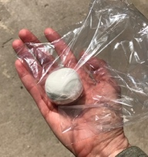 + 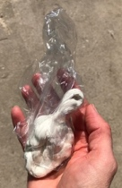 +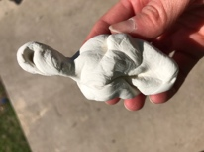 =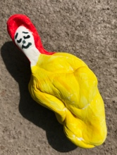

Are You My Mother? Fun easy bird for little hands to make. Encourages teamwork with a parent or other adult.
- Small ball of Model Magic. Squeeze gently in the middle.
- Pinch and carefully in bird shape.
- Add wire legs as shown.
- Add color with markers or paint.
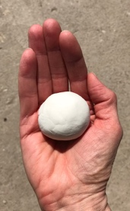 + 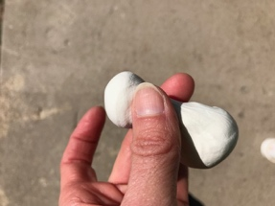 + 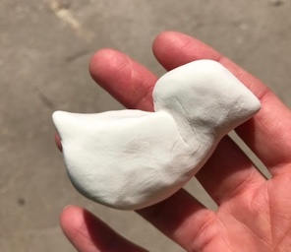 +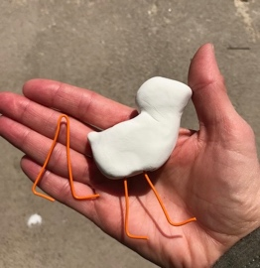 =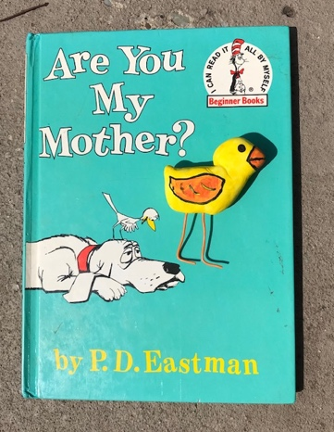
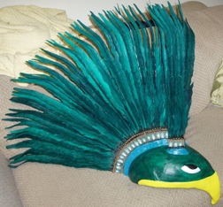 King of the Birds: A Mayan Folktale
Resource: How the King of Birds was Chosen at www.firstpeople.us

Introduces theater art elements:
- Costume
- Movement
- Speaking
- Applause!
SJacket Supplies:
- Felt
- Glue Gun
- T-Shirt
- Scissors
For pattern go to: https://www.annmarienewman.com/creative-directions-for-the-teller
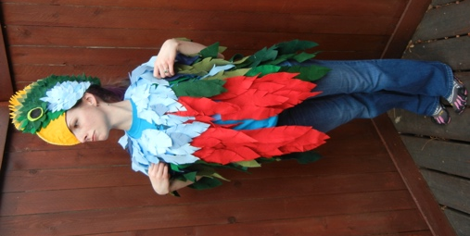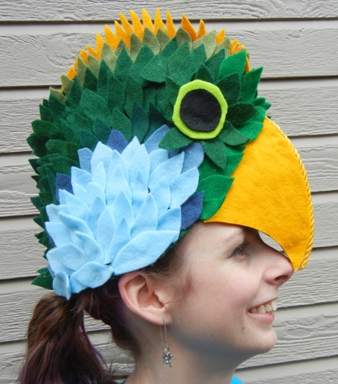
The Quetzal Bird!

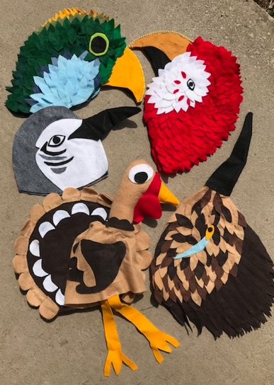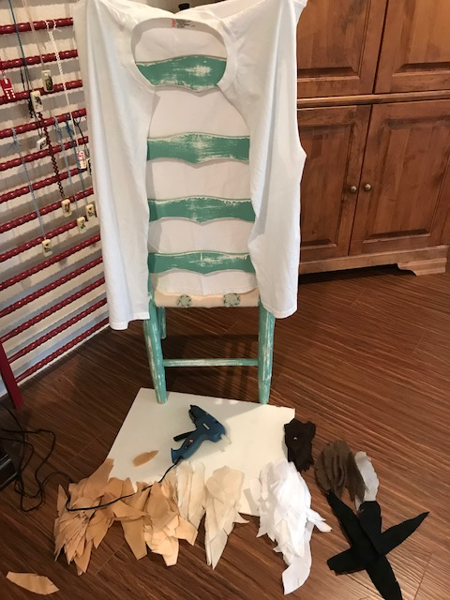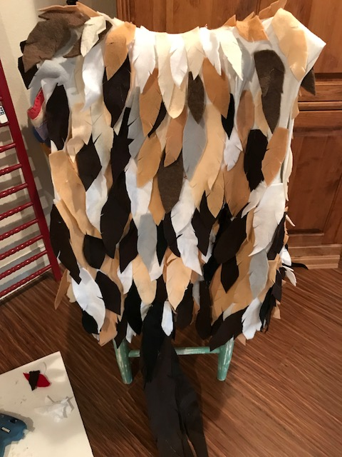
Remove the sleeves, cut the t-shirt open in the front and start glueing! Leaves can be cut free style in various sizes! The above is the roadrunner’s vest of feathers.

Celebrating Creativity through
ART-full
approaches in storytelling!
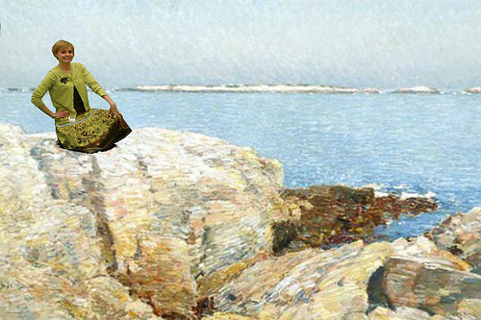

- For a list of my favorite books, please see https://www.annmarienewman.com/story-art-extras

- I am always experimenting and exploring new directions in my quest to merge stories with the visual arts. To keep up with my journey, check my StoryART pages periodically.

- https://annstoryart.wordpress.com Practising ARTitude: Expressing gratitude for art in its many disciplines. (Personal blog.)

@2018 Ann Marie Newman

